**1.Move the Picture(Html)**

<html>

<head>

<title> Moving Elements </title>

<script type="text/javascript" src="2move.js">

</script>

</head>

<body>

<form name="myform">

X Co-ordinate : <input type="text" id="x"/> <br/><br/>

Y Co-ordinate : <input type="text" id="y"/> <br/><br/>

<input type="button" value="Move" onclick="move()"/>

</form>

<div id="img" style="position:absolute;top:100px;left:200px">

<img src="picture1.jpg" width="200px" height="200px">

</div>

</body>

</html>

**Javascrpt**

function move()

{

var x=document.getElementById("x").value;

var y=document.getElementById("y").value;

var dom=document.getElementById("img").style; dom.left=x+"px"; dom.top=y+"px"; }

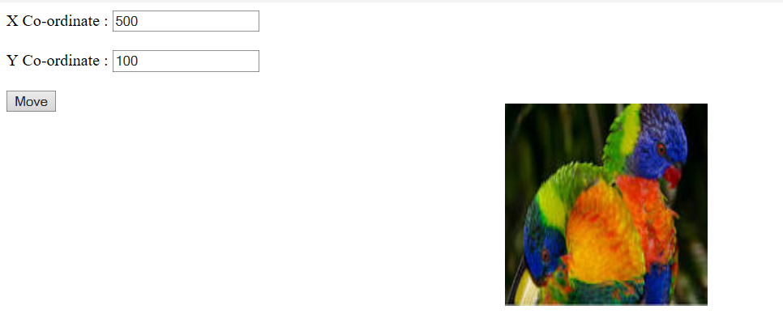

**2.Elements Visibility**

<html>

<head>

<title> Elements Visibility </title>

<script type="text/javascript" src="3visible.js">

</script>

</head>

<body>

<center>

<form name="myform">

<input type="button" value="Appear/Disappear" onclick="vis()"/>

</form>

<br><br><br>

<div id="img" style="visibility:visible">

<img src="picture1.jpg" width="350px" height="350px">

</div>

</center>

</body>

</html>

**Javascript**

function vis()

{

var dom=document.getElementById("img").style;

if(dom.visibility=="visible") dom.visibility="hidden"; else dom.visibility="visible";}

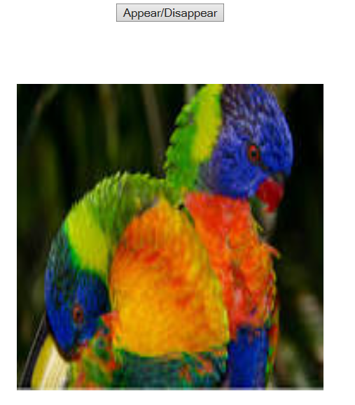 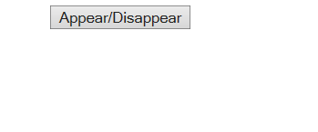

**3.Foreground and Background colours**

<html>

<head>

<title> COLORS </title>

<script type="text/javascript" src="4color.js">

</script>

</head>

<body>

<center>

<form name="myform">

ForeGround-Color: <input type="text" id="fgcolor" onchange="color('fg',this.value)"/> <br/><br/>

Background-Color: <input type="text" id="bgcolor" onchange="color('bg',this.value)"/> <br/><br/>

</form>

<br><br><br>

<h1> Color of this Text will be Changed </h1>

</center>

</body>

</html>

**Javascrpit**

function color(where,clr)

{

if(where=="fg")

document.body.style.color=clr;else document.body.style.backgroundColor=clr;}

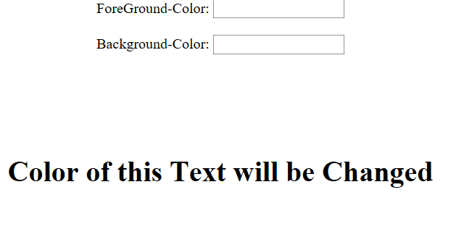 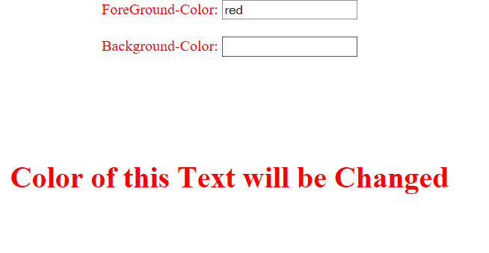

**4.Changing Font Style**

<html>

<head>

<title> Changing Font </title>

<style type="text/css">

.reg {font-size:20pt;font:sans-serif;}

</style>

</head>

<body>

<center>

<br><br><br>

<p class="reg">The

<a style="color:blue;" href="http://www.gitam.edu"

onmouseover="this.style.color='red';

this.style.font='italic 30pt Times';"

onmouseout="this.style.color='blue';

this.style.font=' 20pt sans-serif';"">

HTML </a>

is a Hyper Text Mark Up Language. </p>

</center>

</body>

</html>

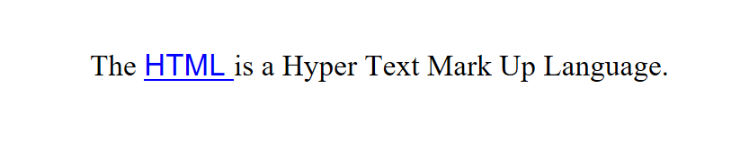

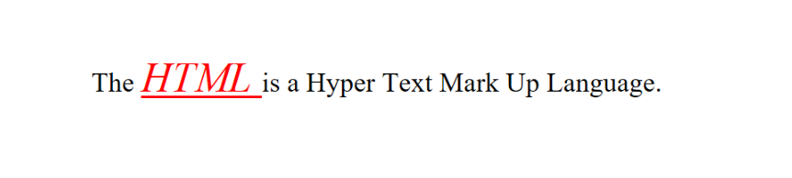

**5.Mouse Pointer location event**

<html>

<head>

<script type="text/javascript" src="8mousel.js">

</script>

</head>

<body onclick="find(event)">

<form>

Within the ClientArea:<br>

X-COORD : <input type="text" id="t1"/><br>

Y-COORD : <input type="text" id="t2"/><br><br>

Within the Screen Area:<br>

X-COORD : <input type="text" id="t3"/><br>

Y-COORD : <input type="text" id="t4"/>

</form>

</body>

</html>

**Javascript**

function find(evt)

{

document.getElementById("t1").value=evt.clientX;document.getElementById("t2").value=evt.clientY;

document.getElementById("t3").value=evt.screenX; document.getElementById("t4").value=evt.screenY;

}

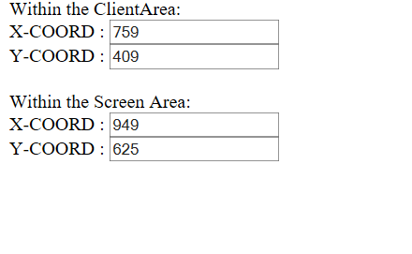

**6.Dragging the elements**

<html>

<head>

<script type="text/javascript" src="drags.js">

</script>

</head>

<body>

<div style="position:absolute;top:200px;

left:0px;font:italic 30pt Times;

background-color:pink;"

onmousedown="grab(event)">How</div>

<div style="position:absolute;top:200px;

left:100px;font:italic 30pt Times;

background-color:violet;"

onmousedown="grab(event)">Hi</div>

<div style="position:absolute;top:200px;

left:200px;font:italic 30pt Times;

background-color:yellow;"

onmousedown="grab(event)">you</div>

<div style="position:absolute;top:200px;

left:300px;font:italic 30pt Times;

background-color:wheat;"

onmousedown="grab(event)">are</div>

</body>

</html>

**Javascript**

var diffX,diffY,theElement;

function grab(evnt)

{ theElement=evnt.currentTarget;

var posX=parseInt(theElement.style.left);

var posY=parseInt(theElement.style.top);

diffX=evnt.clientX-posX;

diffY=evnt.clientY-posY;

document.addEventListener("mousemove",mover);

document.addEventListener("mouseup",dropper);

}

function mover(evnt)

{

theElement.style.left=

(evnt.clientX-diffX)+"px";

theElement.style.top=

(evnt.clientY-diffY)+"px";

}

function dropper(evnt)

{

document.removeEventListener("mouseup",dropper);

document.removeEventListener("mousemove",mover);}

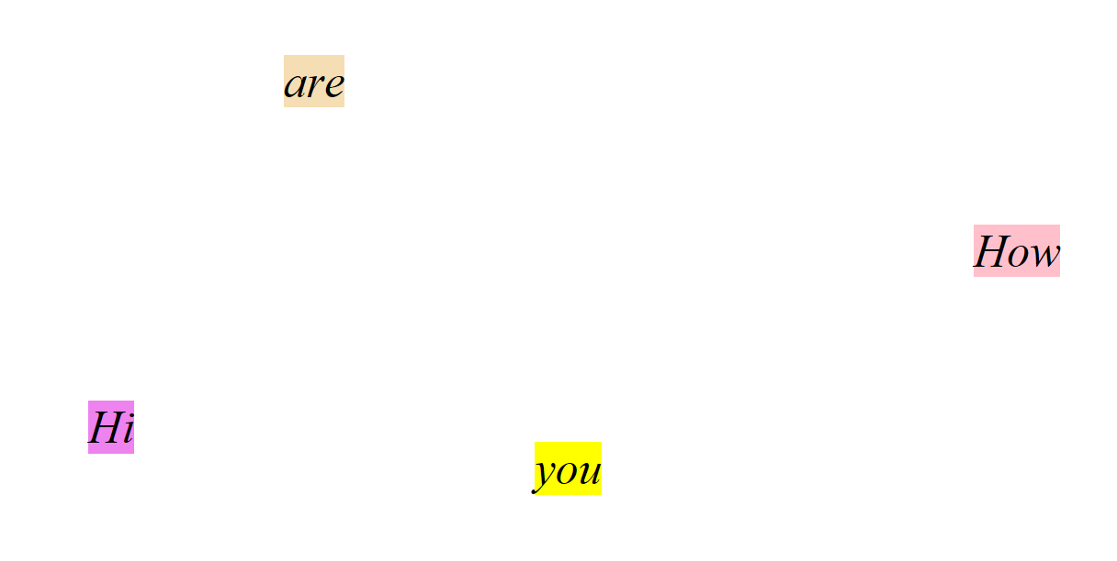

**7.Moving Text**

<html>

<head>

<script type="text/javascript" src="slmove.js">

</script>

</head>

<body onload="init()">

<div id="txt" style="color:red;

font:italic 20pt sans-serif;position:absolute;left:100px;top:100px;">

Hi.It's a moving text. </div>

</body>

</html>

**Javascript**

var dom,x,y,finalx=300,finaly=300;

function init()

{

dom=document.getElementById("txt").style;

x=dom.left;

y=dom.top;

x=x.match(/\d+/);

y=y.match(/\d+/);

moveit(x,y);

}

function moveit(x,y)

{

if(x!=finalx)

if(x>finalx) x--;

else

if(x<finalx) x++;

if(y!=finaly)

if(y>finaly) y--;

else

if(y<finaly) y++;

dom.left=x+"px";

dom.top=y+"px";

if((x!=finalx) || (y!=finaly))

{

setTimeout("moveit("+x+","+y+")",1);

}

}



**8.Stacking of Elements**

<html>

<head>

<title> STACKING ELEMENTS </title>

</head>

<body>

<img src="picture1.jpg" width=200 height=200 style="position:absolute;left:150px;top:150px;z-index:0;" id="first" onclick="totop('first');"/>

<img src="picture2.jpg" width=200 height=200 style="position:absolute;left:200px;top:200px;z-index:0;" id="sec" onclick="totop('sec');"/>

<img src="picture3.jpg" width=200 height=200 style="position:absolute;left:250px;top:250px;z-index:0;" id="third" onclick="totop('third');"/>

<script type="text/javascript" src="stack.js">

</script>

</body>

</html>

**Javascript**

tp="first";

function totop(newtp)

{

dom1=document.getElementById(tp).style;

dom2=document.getElementById(newtp).style;

dom1.zIndex="0";

dom2.zIndex="10";

tp=newtp;}

